**EX. NO: 3 DATE: 15/09/2020**

**Creating And Pushing To GitHub Repository**

**Screenshots:**

1. **GIT GUI:**

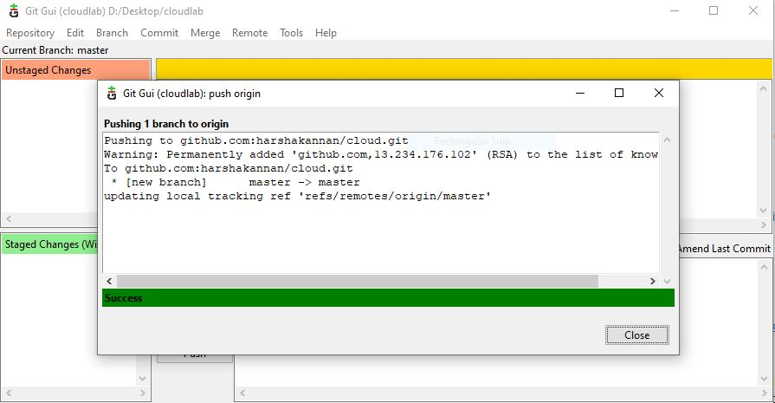

1. **GitHub Repository:**

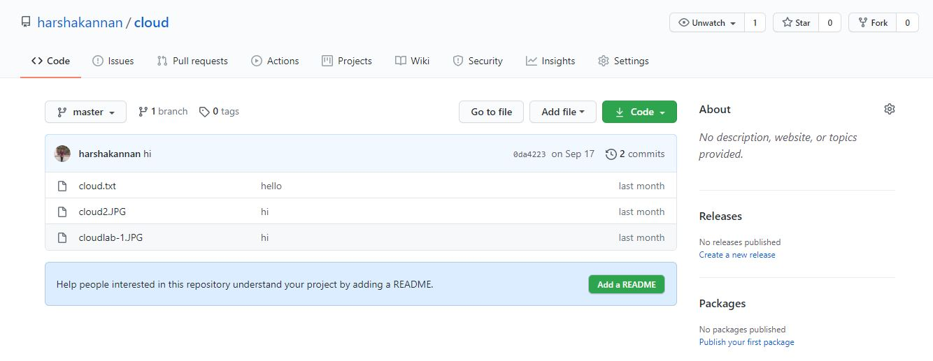

**Result:**

Hence, files from a folder have been pushed into a specified GitHub Repository Successfully**.**